Agenda- To Show Last Signed In User in the Report for a particular user

We need one report for the showing now we can create the report under the Data-Admin-Operator-ID

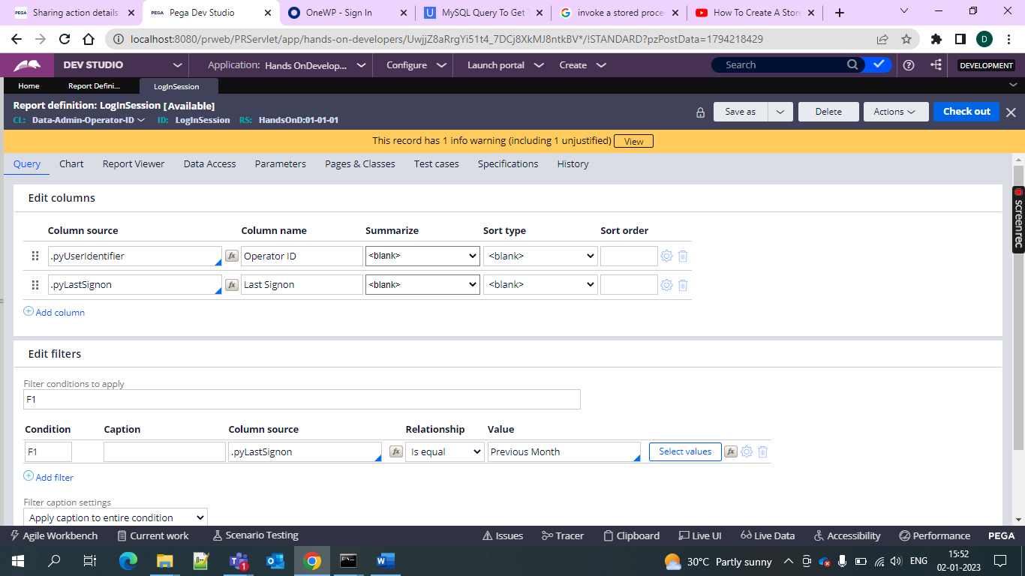

And give the filter as the previous month and then get the usage and then see the resultds

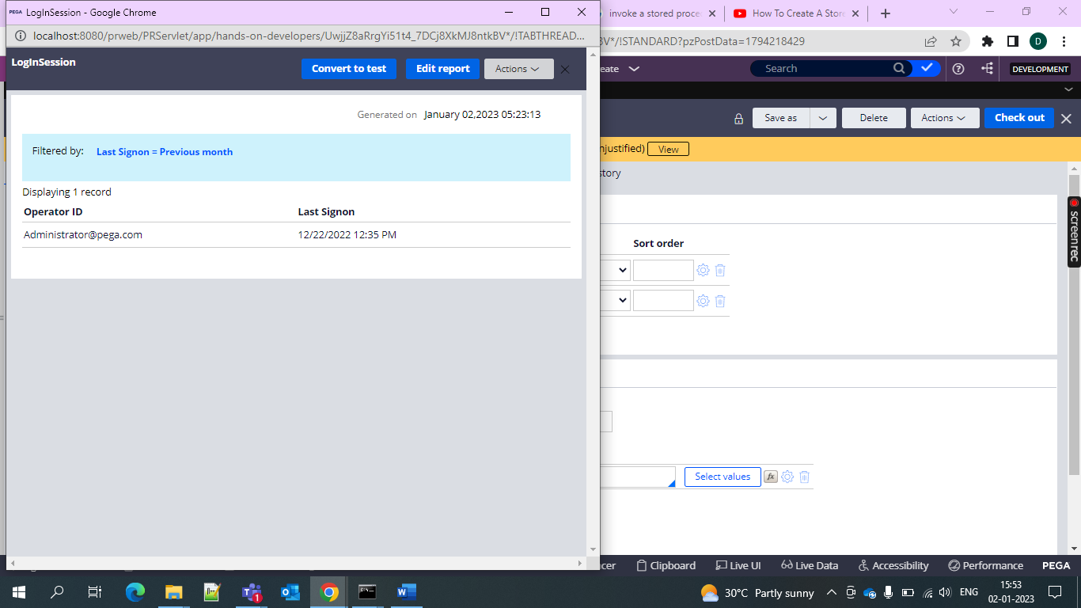

And hence the operator and then the logged in time